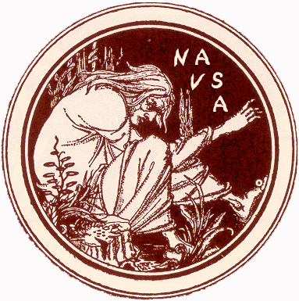
N A V S A
Department of English
Purdue University
500 Oval Drive • West Lafayette, IN 47907-2038
FAX: (765) 494-3780

URL: http://www.purdue.edu/NAVSA
Email: navsa@purdue.edu

NAVSA BEST BOOK OF THE YEAR: NOMINATION FORM
for books published in 2014*

1) Author and Title of book (please include complete bibliographic citation)

Last Name, First. Title of Book. City: Press, Date.

2) Author’s Address and Email

Address Line 1
Address Line 2
City, State, Zip
Country

Email

3) Primary Contact at Publisher: Name, Address, and Email

Address Line 1
Address Line 2
City, State, Zip
Country

Email

4) Nominator’s Name, Address, and Email (or “Self” if self-nominated)

Address Line 1
Address Line 2
City, State, Zip
Country

Email

*The prize is contingent on the author’s attendance at the next NAVSA conference for the entire range of conference dates. Authors must appear in person at the special session or they are not eligible for the award. Conference dates are available on the NAVSA website.

